1. Pre-Note: This project is a separate project for consumer.  
   Note the project name is JmsConsumer.Graphical user interface, text, application, email

   Description automatically generated
2. Graphical user interface, text, application, Word

   Description automatically generated  
   We are done with configuration for Consumer app.
3. Now, let’s create a separate class to consume the msgs from a queue.
4. 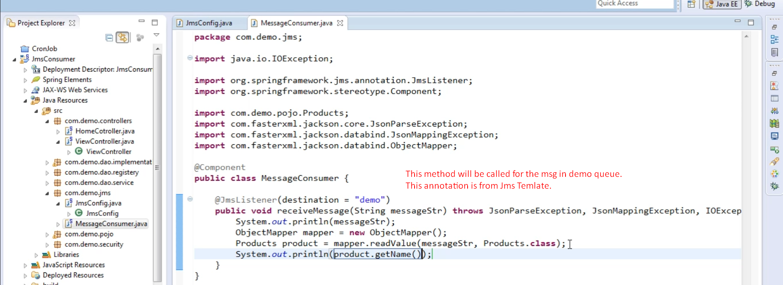
5. Graphical user interface, text, application

   Description automatically generated